|  |
| --- |
| CSC 533 Artificial Intelligence and Heuristic Programming |
| Bayesian Networks |
| Project 2 |

|  |
| --- |
| Chris Townsend & Shanon Clemmons  11/23/2009 |

# Report

* Shortness of breath (dyspnea) may be due to one or more of tuberculosis, lung cancer, or bronchitis, or none of them.
  + Node
    - Dyspnea
    - Tuberculosis
    - Lung Cancer
    - Bronchitis
  + Links
    - Tuberculosis --> Dyspnea
    - Lung Cancer --> Dyspnea
    - Bronchitis --> Dyspnea
* A recent visit to Asia increases the chances of tuberculosis, while smoking is known to be a risk factor for both lung cancer and bronchitis.
  + Node
    - Asia Travel
  + Links
    - Asia Travel --> Tuberculosis
* The results of a single chest X-ray do not discriminate between lung cancer and tuberculosis.
  + Node
    - Chest X-Ray
  + Link
    - Lung Cancer --> Chest X-Ray
    - Tuberculosis --> Chest X-Ray

# Statistical Data

See Attached Excel Worksheet

# Network

# Tables

|  |
| --- |
| P( Asian Travel) |
| 0.5% |

|  |
| --- |
| P(Smoking) |
| 19.8% |

|  |  |
| --- | --- |
| Asian Travel | P(Tuberculosis| Asian Travel ) |
| True | 5.00% |
| False | 4.11% |

|  |  |
| --- | --- |
| Smoking | P(Lung Cancer | Smoking) |
| True | 0. 23% |
| False | 0.06% |

|  |  |
| --- | --- |
| Smoking | P(Bronchitis | Smoking) |
| True | 18.82% |
| False | 4.45% |

|  |  |  |
| --- | --- | --- |
| Tuberculosis | Lung Cancer | P(Chest X-Ray | Tuberculosis, Lung Cancer |
| False | False | 23.50% |
| False | True | 84% |
| True | False | 92% |
| True | True | 95% |

|  |  |  |  |
| --- | --- | --- | --- |
| Tuberculosis | Lung Cancer | Bronchitis | P(Dyspnea | Tuberculosis, Lung Cancer, Bronchitis) |
| False | False | False | 1.5% |
| False | False | True | 20.7% |
| False | True | False | 40% |
| False | True | True | 50% |
| True | False | False | 43.2% |
| True | False | True | 50% |
| True | True | False | 60% |
| True | True | True | 75% |

# ScreenShots

## Asian Travel

## 

## Smoker With Lung Cancer

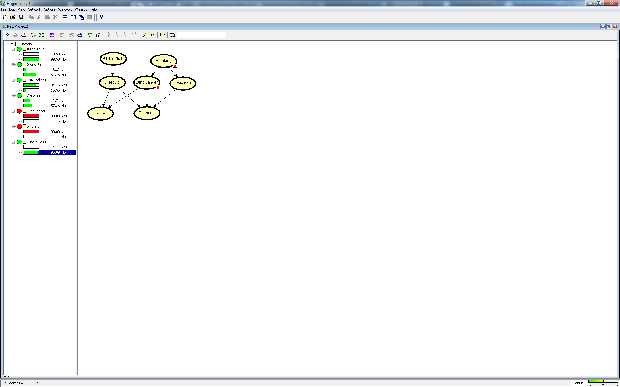

## Tuberculosis , Lung Cancer & Bronchitis

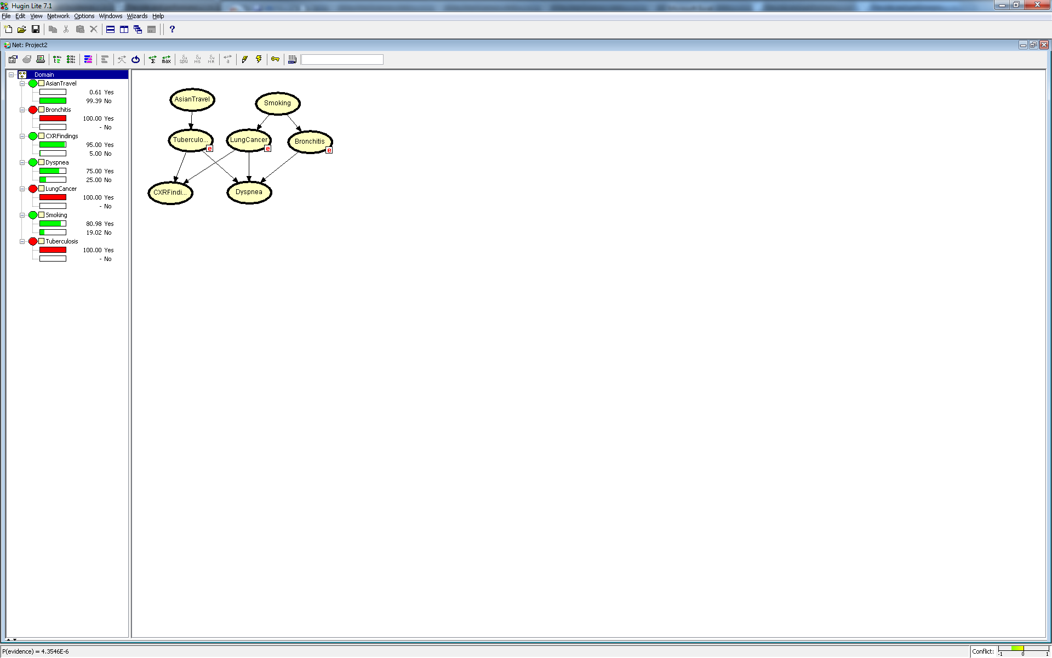

# Contributions

* Chris
  + Research on Statistically Information - Excel Document
  + Initial Design of Bayesian Network
* Shanon
  + Report
  + PowerPoint